**WIFI POWER SOCKET**

This is a microcontroller switch that is controlled with mobile and computer via WiFi Connection. The Wifi Power Socket generates a protected WiFi Hotspot named Switch and a serial number for the switch. Example WiFi Hotspot named “switch01” with different password for each Wifi Power Socket. When you connect to the WiFi you can automatically switch off and switch on the Electric Switch remotely with your phone or laptop.

**SAFETY WARNING**

Please read the installation instructions carefully and use accordingly

Don’t open the switch for any reason when it is connected to the power supply.

Please if you have problems or difficulties contact us [www.mindage.co](http://www.mindage.co) or send email to nonsodavilo@mindage.co

**GERNERAL INSTALLATION AND USE INSTRUCTIONS**

All connections are made according to the IEE Wiring regulations.

1. Socket the plug of the Wifi Power Socket to AC power mains you want to control.

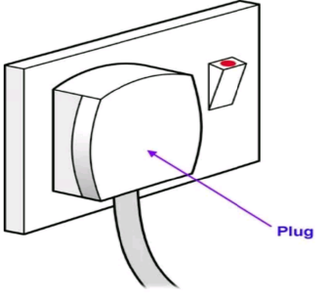

1. Leave the WiFi Power Socket ON for a minute and then switch ON your mobile WiFi or Laptop WiFi.

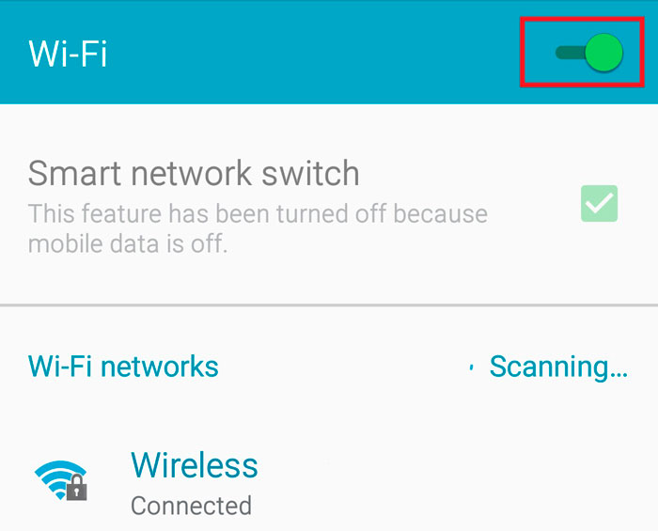

1. Connect to the WiFi that has the name of your WiFi Power Socket and enter the password attached to the manual.
2. Open your main browser go to the address box:
3. To OFF enter <http://192.168.4.1/led?state=off>
4. To ON enter <http://192.168.4.1/led?state=on>
5. Save them